

Foundations of Programming

Assignment No.: 19
PROBLEM STATEMENT: Create Structure EMPLOYEE for storing details (Name, Designation, gender, Date of Joining and Salary). Define function members to compute a) total number of employees in an organization b) count of male and female employee c) Employee with salary more than 10,000 d) Employee with designation “Asst Manager”

OBJECTIVE:

- To understand the use of structures in C programming.
- To store and manage employee records using structures.
- To perform operations such as counting and filtering employee data

THEORY:
In the C programming language, a structure is a user-defined data type that groups related variables of different data types under a single name. Structures are widely used for representing records such as employee information. In this program, a structure named EMPLOYEE is created to store employee details such as name, designation, gender, date of joining, and salary. By using loops and conditional statements, the program can calculate the total number of employees, count male and female employees, find employees whose salary is greater than 10,000, and display employees having the designation 'Asst Manager'.
PLATFORM: Linux

INPUT: Employee details such as Name, Designation, Gender, Date of Joining and Salary.

OUTPUT: Displays total number of employees, count of male and female employees, employees with salary greater than 10,000, and employees with designation 'Asst Manager'.

CODE:
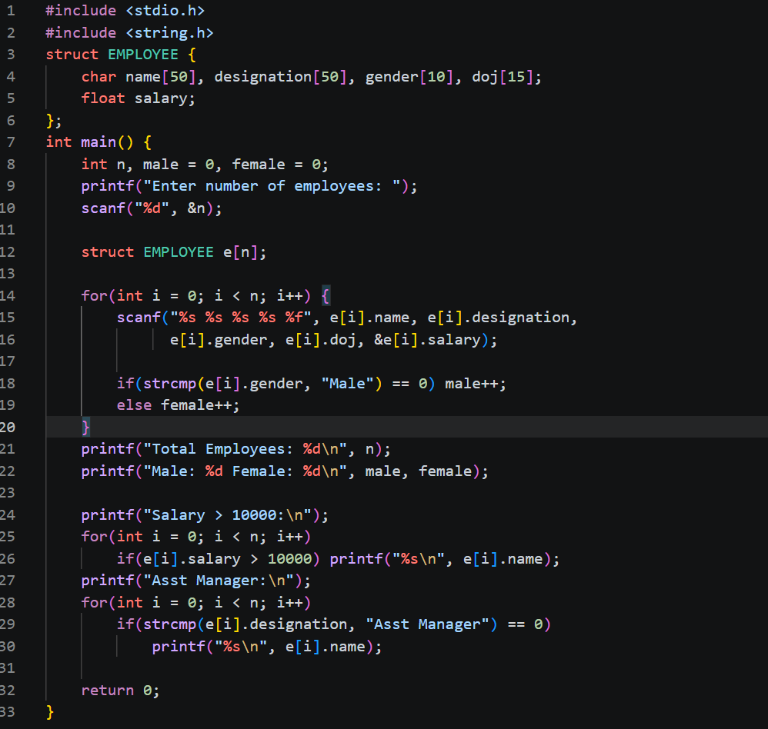
SAMPLE INPUT:
Enter number of employees: 2
Employee 1: Ravi, AsstManager, Male, 12-05-2022, 15000
Employee 2: Anita, Clerk, Female, 10-01-2023, 8000
SAMPLE OUTPUT:
Total number of employees = 2
Male employees = 1
Female employees = 1
Employees with salary more than 10000: Ravi
Employees with designation AsstManager: Ravi

CONCLUSION: Thus, the C program successfully demonstrates the use of structures to store employee details and perform various operations such as counting employees, identifying employees with salary greater than 10,000, and displaying employees with the designation 'Asst Manager'.

FAQs:
- How does a structure in the C programming language help in organizing multiple related data items such as employee details?
Soln: A structure in C helps organize multiple related data items by grouping different types of variables (like name, salary, and designation) under a single name. This makes it easier to manage and access all related information of an entity, such as an employee, in one place. It improves code clarity, reduces complexity, and allows handling of complex data efficiently.
- Why are structures preferred over simple variables or arrays when managing records like employee information?
Soln: Structures are preferred over simple variables or arrays because they allow grouping of different types of data (such as name, salary, and designation) into a single unit. Unlike arrays, which store only similar data types, structures can store mixed data types, making them ideal for representing real-world records like employee details. This improves data organization, readability, and makes programs easier to manage and maintain.
- How can conditional statements and functions be used with structures to filter employees based on salary or designation?
Soln: Conditional statements (like if) and functions can be used with structures by checking specific fields of each employee record. For example, inside a function, you can loop through an array of structures and use conditions such as if (salary > 10000) or if (strcmp(designation, "Asst Manager") == 0) to filter employees. Functions help organize this logic separately, making the code modular, reusable, and easier to understand.

